**Name: Club:**

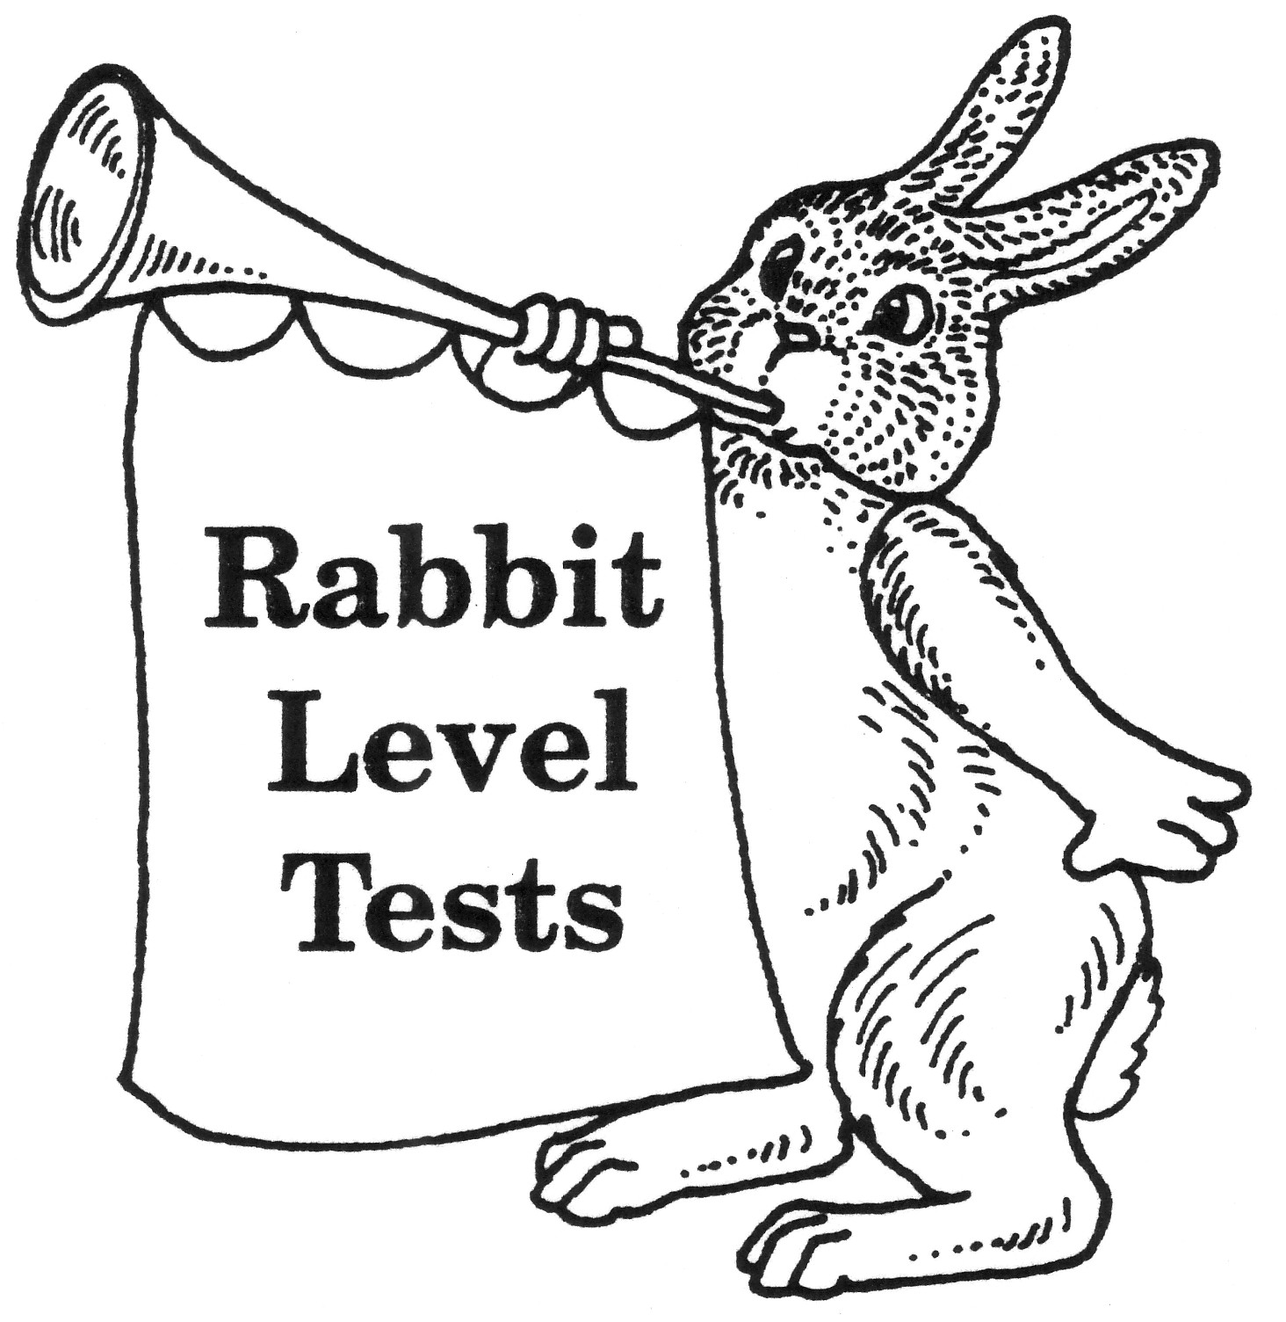

# UNIVERSITY OF CALIFORNIA

# COOPERATIVE EXTENSION

**SANTA BARBARA COUNTY**

**4-H YOUTH DEVELOPMENT PROGRAM**

## RABBIT LEVEL TESTS

# Levels 1-4

**& Level A**

Raising rabbits is an interesting and rewarding 4-H project. The 4-H Rabbit Level Tests help you learn what you need to know about your 4-H Rabbit Project. This is a five-year program for 4-H Rabbit Project members. You may only complete one level per year.

Each level has a minimum number of items that must be completed to earn that level award and they are listed on each level test. There are mandatory items that must be completed and items that you can decide to complete. As you complete the mandatory and additional items, the project leader must initial and date those items when completed.

When you have completed all items required in a level, your project leader will sign the Certificate of Achievement at the back of the packet. When you complete one level, you can start the next one. Keep the signed certificate as part of your 4-H records. The project leader will give out level testing rabbit pins for each level.

BD06271_

**Name: Club:**

# RABBIT LEVEL TEST



**LEVEL 1**

**The Rabbit Explorer**

You must complete a total of nine questions but the first five questions are **mandatory\*.**

|  |  |  |
| --- | --- | --- |
| Leader  Initials |  | Date |
|  |  |  |
|  |  |  |
|  |  |  |
|  |  |  |
|  |  |  |
|  |  |  |
|  |  |  |
|  |  |  |
|  |  |  |
|  |  |  |
|  |  |  |

**1\*.** Identify and describe three breeds of domestic rabbits.

**2\*.** Name and point out the following parts of a rabbit:

a. hindquarters

b. loin

c. saddle

d. shoulder

e. belly

f. chest

g. dewlap

h. hock

**3\*.** Demonstrate (show and tell) how to lift, hold, and carry a rabbit.

**4\*.** Know the standard weights of your breed of rabbit.

**5\*.** Demonstrate how to tell the sex of a young rabbit.

6. Describe a good type of cage and the equipment a beginner needs.

7. Explain what feeds are important for rabbits.

8. Give at least two reasons why you take the doe to the buck’s cage

for breeding.

9. Describe how to prepare a nest for a doe and when put it in a hutch

before kindling.

10. Explain how to tattoo a rabbit.

11. Talk or Demonstrate at a club level. Provide title, date given, and

signature of project or community leader.

**Name: Club:**

# RABBIT LEVEL TEST

**LEVEL 2**

**The Junior Rabbit Raiser**

You must complete a total of eight questions but the first five questions are **mandatory\*.**

|  |  |  |
| --- | --- | --- |
| Leader  Initials |  | Date |
|  |  |  |
|  |  |  |
|  |  |  |
|  |  |  |
|  |  |  |
|  |  |  |
|  |  |  |
|  |  |  |
|  |  |  |
|  |  |  |
|  |  |  |

**1\*.** Name and describe six breeds of domestic rabbits.

**2\*.** Participate in showmanship. Provide date, place, name of event,

award won.

**3\*.** Make a project or craft (still exhibit) that relates to your rabbit and

enter it at either exhibit day, fair, or recognized 4H event.

**4\*.** Describe or demonstrate what you can do to protect your rabbit

during hot and cold weather.

**5\*.** Visit an animal shelter and learn how their rabbits are cared for.

Describe in detail.

1. Describe desirable characteristics of a meat-type rabbit’s

hindquarters, loin, saddle, and shoulders.

7. Properly worm a rabbit with test administrator.

8. Attend two shows, clerk or ramrod for at least one judge. Write

breed that you worked for, # of rabbits in breed, and signature of judge.

9. Describe or demonstrate how to sanitize your rabbit equipment.

10. Talk or Demonstrate at a county event. Provide title, date, award

won, signature of event coordinator, and photo if possible.

11. Describe and give control measures for at least three diseases or

problem conditions of rabbits such as ear canker, sore hock,

diarrhea, or vent disease.



**Name: Club:**

# RABBIT LEVEL TEST

**LEVEL 3**

**4-H Senior Rabbit Raiser**

You must complete a total of seven questions but the first five questions are **mandatory\*.**

|  |  |  |
| --- | --- | --- |
| Leader  Initials |  | Date |
|  |  |  |
|  |  |  |
|  |  |  |
|  |  |  |
|  |  |  |
|  |  |  |
|  |  |  |
|  |  |  |
|  |  |  |
|  |  |  |
|  |  |  |

**1\*.** Write out a pedigree for one of your rabbits.

**2\*.** Demonstrate how to check a doe for pregnancy.

**3\*.** Explain and describe three diseases, parasites, or problem conditions

not covered in level 2, item 11.

**4\*.** Show your rabbit in at least two rabbit shows (cumulative). Keep

show cards/reports for rabbit shown, date, and place shown.

**5\*.** Explain to test administrator how to recognize a sick rabbit. Describe

symptoms, possible illness, and how to treat.

6. Compare two breed of rabbits from different classes, body types, and

varieties. Write report or explain in detail to test administrator.

7. Invite and introduce a guest speaker at one of your club meetings.

Guest speaker can be someone who can promote meat rabbits. (i.e.

raising, butchering, marketing, feeding, or cooking of meat rabbits.) or

teach showmanship, or discuss any other rabbit topic, breeding, housing

showing, etc.

8. Tattoo a rabbit

9. Show completed rabbit project forms for at least one year in

record book. Note county winner, medalist, club award if any.

10. Make a learning poster and exhibit it at a 4-H event, fair, or

competition and record award won if any.

11. Talk or demonstrate at the regional level. Provide title, date, and

signature of event coordinator.



**Name: Club:**

# RABBIT LEVEL TEST

**LEVEL 4**

**The Rabbit Leader**

You must complete a total of six questions but the first four questions are **mandatory**\*.

|  |  |  |
| --- | --- | --- |
| Leader  Initials |  | Date |
|  |  |  |
|  |  |  |
|  |  |  |
|  |  |  |
|  |  |  |
|  |  |  |
|  |  |  |
|  |  |  |

**1\*.** Complete a junior leader or teen leader project in the rabbit project.

**2\*.** Plan a rabbit based community pride project that project members

can participate in. Get signature of supervisor, # of hours completed

describe work done.

**3\*.** Prepare teaching materials for use at project meetings. Provide

copy of one meetings materials and explain to test administrator how

they were presented.

**4\*.** Explain all the parts of a pedigree, legs, how to “grand” a rabbit and

materials needed

5. Assist younger members in designing and constructing needed

equipment.

6. Help plan a 4-H rabbit event. Provide information on show committees

your role in the event, details of the event, clubs, members, and

counties served.

7. Speak on a rabbit-based subject before an organization other than

your 4-H club. (ie fair, FFA, feed store) Provide topic discussed and

date.

8. Assist at a rabbit show as a clerk, secretary, recorder or an assistant

to the judge for at least four breeds. List breeds, # in each breed,

get judges signatures of breeds assisted, date, and show information.

9. Talk or demonstrate at the state level. Provide title, date, and

signature of event coordinator.



**Name: Club:**

# RABBIT LEVEL TEST

**LEVEL A**

**The Rabbit Researcher**

This level, the Rabbit Researcher can be done at any time. You don’t have to

|  |  |  |
| --- | --- | --- |
| Leader  Initials |  | Date |
|  |  |  |
|  |  |  |
|  |  |  |
|  |  |  |
|  |  |  |
|  |  |  |
|  |  |  |
|  |  |  |
|  |  |  |

complete levels 1-4 in order to complete Level A. You must complete both steps

I and II.

Prepare a paper of 3000 words or more, or a portfolio on one or more of the

following subjects. Orally summarize report at your rabbit project meeting or

countywide educational event. (see below for portfolio or research topics)

* Management of rabbits.
* Rabbit feeds, feeding, and nutrition.
* Rabbit diseases, address prevention, control, and general sanitation.
* Markets and methods of marketing rabbits.
* Reproduction, breeding, and genetics of rabbits.
* Fur preparation for market, how marketed, and how fur is used.
* Keeping and using records as a basis for improving your 4-H rabbit project.
* Compare and Contrast 5 different breeds of rabbits.
* Track quality of a litter. How many were showable, buck to doe ratio, awards
* won, whether they were added to a breeding program & why

**Name: Club:**

WHAT MIGHT GO INTO A PORTFOLIO?

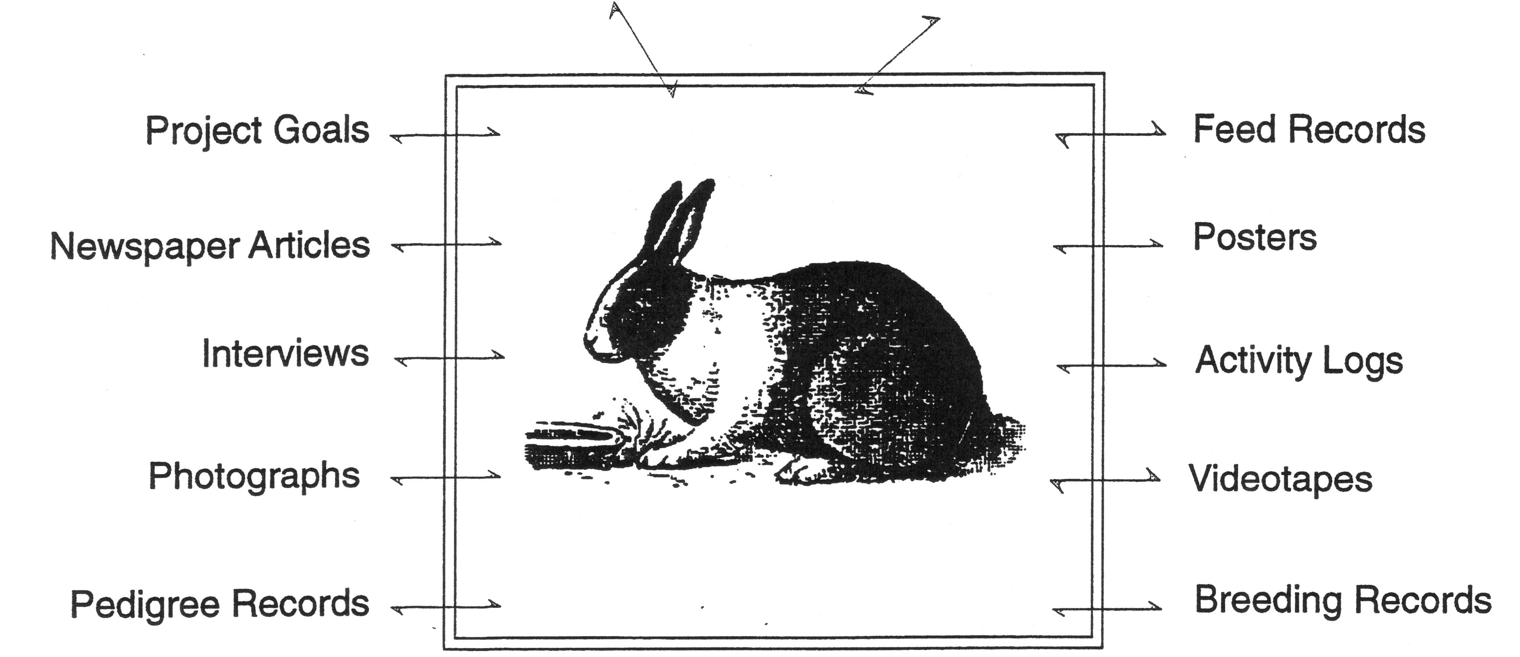

**What Goes Into a Portfolio?**

As you think about what to include in your portfolio you will gain new understandings (even surprises) of the Rabbit Project and of yourself as a Rabbit Raiser. There are no right or wrong answers about what to include in your portfolio, however; they usually include easy-to-find statements about:

* Description of the project.
* Project goals.
* What you did to achieve goals.
* Explain what you learned of this project.

The portfolio should include whatever you think will tell your story the best. For example, statements of project goals, photographs, listing adult volunteers, examples of rabbit breeding, description of your activities, videotapes of events, graphs, charts, selections from your personal journal that you keep on the project, an essay about what you are learning, newspaper clippings about your project, anything that makes sense to you and help tell the story. Most people will probably create individual portfolios, however; teams can also make exciting portfolios for specific activities.