- Ewe
- Weaning
- Trait
- Spring Lamb
- Litter
- Lambing
- Disease
- Ram
- Wether
- Crossbred
- Creep feeding
- Dock
- Breed
- Feces
- Feeder lamb
- Sire
- Ewe Lamb
- Hock
- Scours
- Weaning
- Conformation
- Feeder pig
- Colostrum
Sheep Vocabulary & Terms
Select the correct word to fit the definition from the list on the right.

- _______: The birthing process in sheep.
- _______: Giving lambs extra feed when they are still nursing.
- _______: A castrated male lamb.
- _______: A female sheep that is over one year old.
- _______: Cutting the tails short on baby lambs.
- _______: Male parent of a specific lamb.
- _______: Intact male sheep.
- _______: Offspring produced from the mating of two or more breeds.
- _______: A young female sheep.
- _______: The shape and design of an animal.

Body Parts

Select the correct body part from the list on the right.
- Back
- Belly
- Cheek
- Dewclaws
- Elbow
- Eye
- Ear
- Rump
- Breast
- Muzzle
- Rack
- Hock
- Loin
- Knee
- Twist
- Neck
- Pastern
- Poll
- Leg
- Rump
- Seam
- Sheath
- Shoulder
- Ribs/Side
- Flank
- Stifle
- Tail setting
- Hoof
- Underline
- Dock

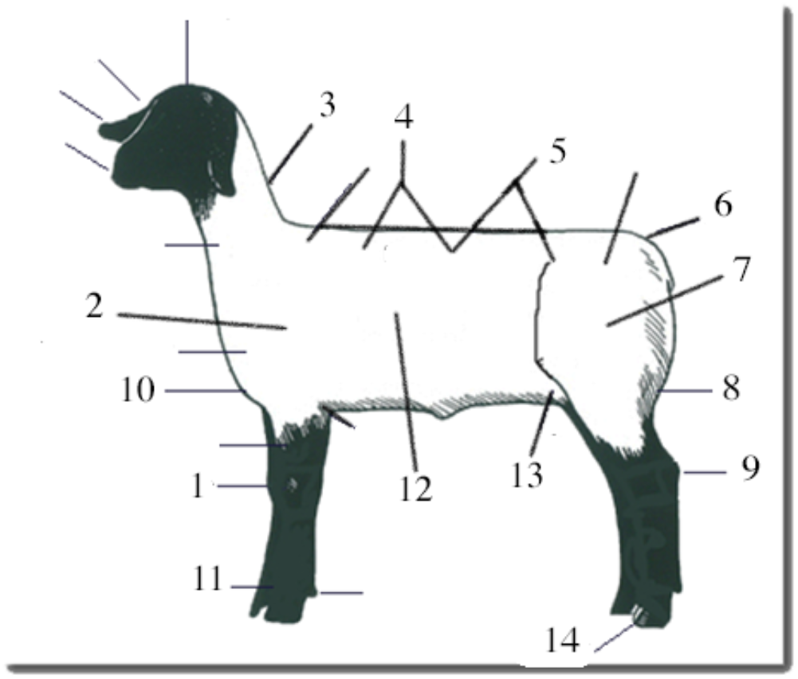

- ________
- ________
- ________
- ________
- ________
- ________
- ________
- ________
- ________
- ________
- ________
- ________
- ________
- ________

Breeds
- Hampshire
- Ram Breeds
- Suffolk
- Dorset
- Finnsheep
- Ewe Breeds
- Merino
- Cheviot
- Icelandic
- Southdown
- Columbia
- Polypay
- Corriedale
Select the correct answer from the list on the right.

- _______: White faced breads are often known as “______”. They usually produce more wool
and more milk.

- _______: Black-faced breeds are sometimes called “_____”, they are used in commercial flocks
to produce market/meat lambs.

- _______: This black faced sheep originated in Southern England. They are large moderately
prolific breed with wool caps, black faces and medium-wool fleeces
- _______: Name three dual purpose breeds _______: _______:
- _______: These sheep were imported to Canada from Finland in 1966 and to the U.S. in 1968,
where they are primarily used to produce crossbred ewes. They are a small- to
medium-sized, fine-boned, open-faced breed with medium-grade, good-staple
length wool. Their wool is mainly white.

General
Select the correct word to complete the sentence correctly or to answer the question
- Sloped top
- Cow hocked
- Strong topped
- Judge
- Auctioneer
- Walks
- 10 – 20 feet
- 5 – 10 feet
- 30 - 50 feet
- Loin
- Rack
- Straight
- 102.3
- 70- 80
- 12-20
- .15” – 0.25”
- .10” - 0.50”
- Sleeps
- Ringworm
- Dermatitis
from the list on the right.

- ________: The ideal market lamb has good muscling and its back is ___?___.
- ________: The normal breathing rate for a lamb is ___?___
- ________: The ideal lamb ___?___ free and easy with strong pasterns and widely set legs.
- ________: It has a long, wide, muscular ___?___ and has a level rump and a high dock setting.
- ________: At market time a meat lamb should have between ___?___ and ___?___ back fat.
- ________: A fungus found on the skin that is contagious is ___?___.
- ________: Normal body temperature of a lamb ___?___.
- ________: In the show ring always keep the lamb between yourself and the ___?___.
- ________: The best distance to look at the side, front, and rear of your lamb is ___?___ feet.
- ________: The normal heart rate for a lamb is ___?___.

Writing a Thank-you Note
In the space below, write a thank-you to someone who has already helped you with your sheep project. This could be your mom or dad, the veterinarian, your project leader, the banker, your neighbor or a friend.

Helpful hint: Start with a greeting. The first sentence should express your appreciation and explain why you are thanking the person. The next sentence should tell a little bit about your project or describe how you used the help. The final sentence should reconfirm your gratitude and sign your name.

Date Test Taken ________________________

Project Leader Signature _________________________

Total Score:

