- Auction
- Beef
- Bovine
- Brand
- Breed
- Bull
- By-Product
- Calf
- Calve
- Cow
- Crossbred
- Dam
- Ear tag
- Finish
- Fitting
- Heifer
- Marbling
- Polled
- Primal Cut
- Purebred
- Ruminant
- Sire
- Steer
Beef Vocabulary & Terms
Select the correct word to fit the definition from the list on the right.

- _______: Bovine male castrated prior to puberty.
- _______ : Animal produced by crossing two or more breeds.
- _______: Refers to a general family grouping of cattle.
- _______: Sexually mature female bovine animal that has usually produced a calf.
- _______: Product made by further processing of leftovers after the primary product has been made
- _______: Mammal whose stomach has four parts – rumen, reticulum, omasum and abomasum.
- _______: An animal that does not have horns because of its genetic traits.
- _______: Male parent.
- _______: Young female bovine prior to the time that she has produced her first calf.
- _______: Permanent identification of cattle, usually made on the hide with hot-iron.

Body Parts

Select the correct body part from the list on the right.
- Back/ Top
- Brisket
- Cannon Bone
- Dewclaw
- Dewlap
- Forearm
- Forehead
- Rear Flank
- Hoof
- Hook Bone
- Knee
- Loin
- Muzzle
- Pastern
- Pin Bone
- Poll
- Point of Shoulder
- Stifle
- Switch
- Tailhead
- Throat
- Top of Shoulder
- Sheath (steer) or Navel (heifers)

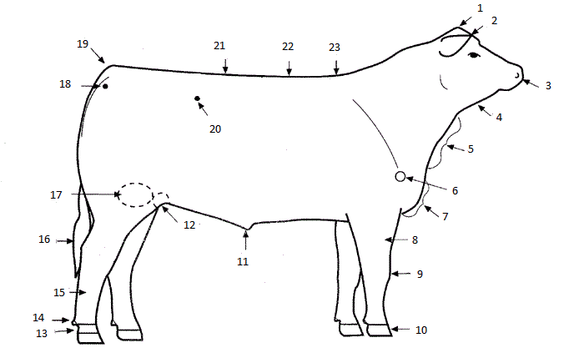

- ___ 13. ___
- ___ 14. ___
- ___ 15. ___
- ___ 16. ___
- ___ 17. ___
- ___ 18. ___
- ___ 19. ___
- ___ 20. ___
- ___ 21. ___
- ___ 22. ___
- ___ 23. ___
- ___ The actual test will require you to identify 15 correctly.

Breeds
Select the correct answer from the list on the right.
- Angus
- Brahman
- Charolais
- Gelbvieh
- Hereford
- Limousin
- Maine-Anjou
- Santa Gertrudis
- Shorthorn
- Simmental

- _______: Large frame, solid white breed from France. They are known for their fast growth rates.

- _______: Solid black polled breed that originated in Scotland. They are the most numerous cattle in the U.S. and are noted for high quality carcasses.

- _______: Large framed cattle from France. This is the largest French breed of cattle. Originating from the Maine and Anjou river valleys.

- _______: White faced, red cattle have horned blood lines and polled bloodlines. They are known for their mothering and foraging ability plus their very docile disposition. They are the second most numerous breed in the U.S.

- _______: Originally called Durhams, this British breed can be red, white or roan in color.

General
Select the correct word to complete the sentence correctly or to answer the question
- Bone
- Brush
- Clockwise
- Counter-clockwise
- Comb
- Decorate
- Deep
- Down
- Fence
- Healthy
- Identify
- Leather
- Long
- Name
- Opposite
- Showstick
- Strong
- Un-healthy
- Up
- Vehicle
- 2.5-3
- 4-6
- 7-18
- 10-24
- 30-50
- 100

from the list on the right.

- ________ Steers should be fed about _____ pounds of dry feed per every 100 pounds of body weight each day.
- ________ Brands, ear tags, and tattoos are all ways to _____ a calf.
- ________ A calf should NEVER be tied behind a _____and pulled while halter breaking.
- ________ _____ is an important by-product of beef animals used for sporting goods.
- ________ A 1,000 pound calf will drink _____ gallons of water per day.
- ________ Poor appetite, droopy ears, and rapid, noisy breathing are signs of a _____ calf.
- ________ Hair should be worked (brushed and blown) forward and _____.
- ________ When entering the ring, walk forward in a _____ direction on the left side of the animal.
- ________ The ideal steer has a level top, _____ forerib, and smooth shoulders.
- ________ A _____ is used to set calves feet and to calm them down.

Writing a Thank-you Note
In the space below, write a thank-you to someone who has already helped you with your beef project. This could be your mom or dad, the veterinarian, your project leader, the banker, your neighbor or a friend.

Helpful hint: Start with a greeting. The first sentence should express your appreciation and explain why you are thanking the person. The next sentence should tell a little bit about your project or describe how you used the help or gift your received. The final sentence should reconfirm your gratitude and don’t forget to sign your name.

