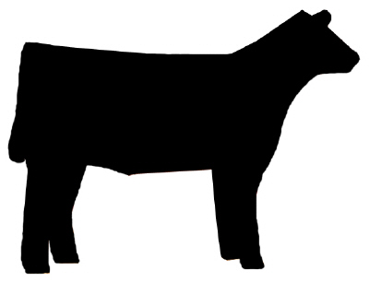

UNIVERSITY OF CALIFORNIA COOPERATIVE EXTENSION
SANTA BARBARA COUNTY
4-H
YOUTH DEVELOPMENT PROGRAM

BEEF PROJECT LEVEL TESTS 1-5

Raising Cattle is an interesting and rewarding 4-H project. The 4-H Beef Project Level Tests will help you learn what you need to know about your 4-H Beef Project. This is a five step program for 4-H Beef Project members. You can only complete one level per year. However during the 2013-14 & 2014-15 program years members may complete up to five levels.

Each level has minimum requirements that must be completed to earn that level award and they are listed on each level test. All skill and written tests require 80% success for passing. Beef Project Level Test 1 is taken at club level. Project leaders will contact the Santa Barbara County 4-H Large Livestock Key Leader for the current test. Skill and Written tests for Levels 2 & 3 will be available at County Events. See the county web site for dates and registration information. Testing fees are due with registration.

Each Level requirement and testing resources can be found in current 4-H Curriculum. The Beef Project Level 1 test questions are found in Book 1”Bite into Beef,” the Level 2 test resource is Cattle Book 2 “Here’s the Beef.” And so on. `

As you complete items required in a level, have your project leader sign the Level Requirement Sheet. Once all requirements are met submit your Level Sheet and the required certificates to the County Office. Level 1 pens will be awarded at club level. Level 2-5 will be awarded at the end of year County Awards.

