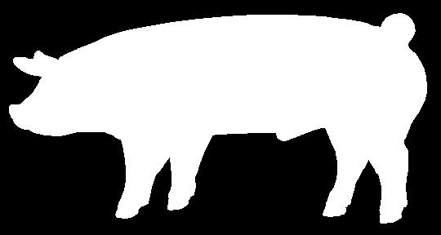

UNIVERSITY OF CALIFORNIA COOPERATIVE EXTENSION
SANTA BARBARA COUNTY
4-H
YOUTH DEVELOPMENT PROGRAM

SWINE PROFICIENCY LEVEL TESTS 1-5

Raising pigs is an interesting and rewarding 4-H project. The 4-H Swine Project Proficiency Level Tests will help you learn what you need to know about your 4-H Swine Project. This is a five step program for 4-H Swine Project members. You can only complete one level per year. However during the 2013-14 and 2014-15 program years members may complete up to five levels.

Each level has minimum requirements that must be completed to earn that level award. All skills and written tests require 80% success for passing. Project Level 1 Test is taken at club level. Project leaders will contact the SB4H Large Livestock Key Leader for the current test each April. Skill and written tests for Levels 2 & 3 will be taken at County Events. See the county web site for dates and registration information. Testing fees are due with registration.

Each Level requirement and testing resources can be found in current 4-H Curriculum. The Swine Level 1 test questions are found in Swine Book 1”Growing with Swine”. The Level 2 test resource is Swine Book 2 “Becoming Swine Smart”. Level 3 Swine resource is Swine Book 3 “Going Whole Hog”.

As you complete items required in each level, have your project leader sign the Level Requirement Sheet. Once all requirements are met submit your Level Sheet and the required certificates to the County Office. The Level 1 pens will be awarded at club level. Level 2-5 will be awarded at the End of Year County Awards.

