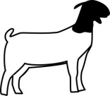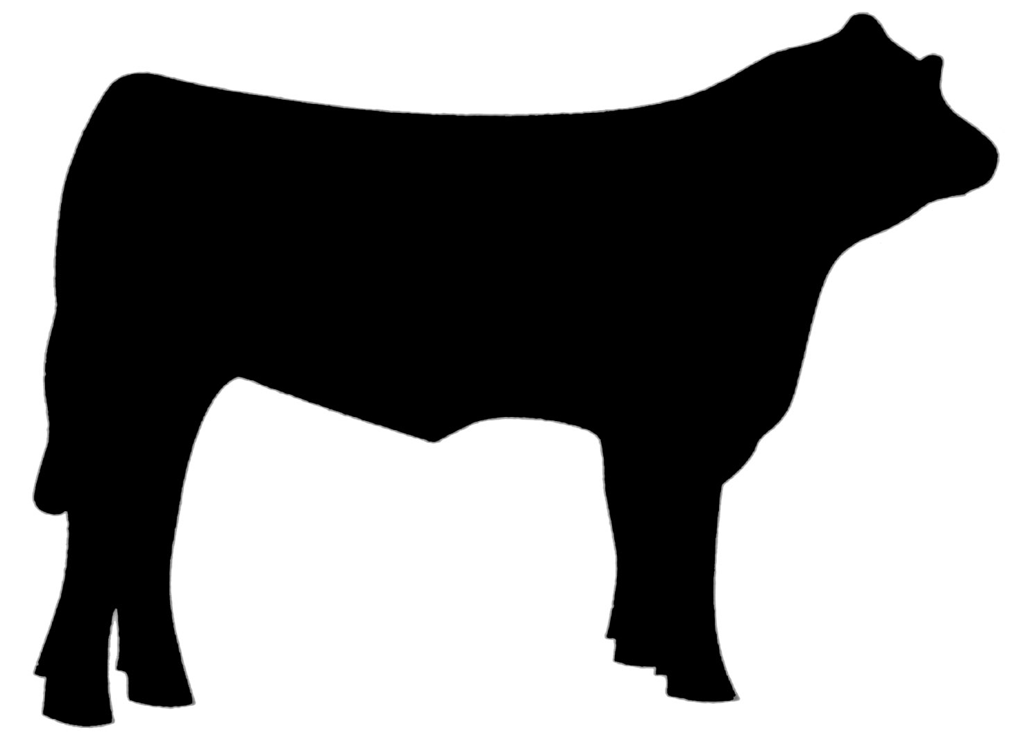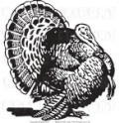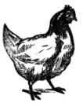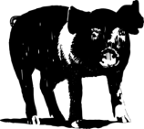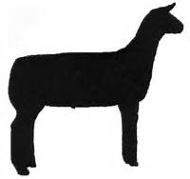

Santa Barbara County 4-H

Project Proficiency Level Testing

The goal of the Santa Barbara County 4-H Project Proficiency Level Testing program is to
- Offer the youth members within Santa Barbara County greater learning opportunities and skill development with mastery in their chosen project area while encouraging self-directed learning.
- Provide a standard of excellence where members are recognized for the knowledge and skills they have mastered.
- Provide guidelines and encouragement to project leaders to enhance and expand project content and experiences.
- Encourage members to expand their 4-H experiences by participating in County, Sectional, State and National 4-H Events
- Develop life skills, increase performance and motivate to youth members and leaders.
- Provide opportunities for youth to develop and build on their Leadership skills.

Participation in the Project Proficiency Level Testing Program is voluntary.
Not all youth or project leaders will find this type of activity rewarding. Many youth enter a project with a personal goal and no desire for mastery of the subject.

Additionally, not all project leaders will choose to go into such depth in each subject area. Completion of Level 1 may be all that is offered by a particular project leader. In the event the project leader chooses not to participate in the Project Proficiency Level Testing Program, a member may contact the SB4H Large Livestock Key Leader for alternatives to meet their needs.
Each of the Five Proficiency Levels is designed to build on the skills and knowledge of the previous level which, increase in scope and difficulty as the member progresses. Proficiency Levels are designed to be completed in two program years, although a very dedicated member maybe able to complete a level requirement in one year. There is no set time limitation for completion of any level.
This program is designed to assist youth in measuring themselves against a “standard of excellence”. Completion of all five levels of a Project Proficiency Level Testing indicates a mastery of a project.
Community and Project Leaders are encouraged to give Project Proficiency Level Testing information to youth members and parents sometime during the first or second year in a project. At this point, the leader allows the member to determine which skills and/or knowledge areas he or she wants to master. Youth members can work on skills in several levels and projects at the same time. The leader’s job is to provide learning opportunities and encouragement, to check for mastery of each requirement in a level and sign off when the member has reached completion.
Large Livestock Proficiency Levels 1-3 (with exception of horse) each have a project knowledge and / or skill, public speaking, event participation and community service component. Each of the Level Requirements and testing resources can be found in current 4-H Curriculum available at the 4-H Mall and at the Santa Barbara County 4-H office. i.e. Swine Level 1 test questions are found in Swine Book 1”Growing with Swine”. The Level 2 test resource is Swine Book 2 “Becoming Swine Smart”. Level 3 Swine resource is Swine Book 3 “Going Whole Hog”. Any additional resources will be listed on the program outline for each species.

Each written test will have vocabulary terms, multiple choice questions and a critical thinking component. A sample of each species Level 1 test is provided with the Project Proficiency Level Testing information available on-line at w.w.w.SB4H.org. Horse Project members shall use the current CHA (Certified Horsemanship Association) Level program.
Proficiency Level Test 4 is dedicated to Leadership Development and Level 5 is an Academic or Research focus.
Proficiency Level 1 is completed at the club / project level. The written knowledge test will be available to Project Leaders only from the SB4H Large Livestock Key Leader each Spring and will change year to year. Club Leaders shall administer and correct tests. Scores will be reported to SB4H Large Livestock Key Leader by June 1st and attached to the Level 1 form upon completion. A passing score of 80% is required for all written and skill tests. Leaders shall not to accept a questionable answer. Incorrectly answered questions indicate an incomplete mastery of the particular skill or body of knowledge. If the youth member is unsure of the correct method or term, use this time to teach the individual and allow the member a minimum of a month to think about it and review if retesting is necessary. The youth member will then be able to return with the knowledge learned and present it with confidence and mastery.
The Large Livestock Proficiency Level 2 & 3 written knowledge and skill tests will be administered a minimum of once each year at a County Event (Presentation Day, Exhibit Day, Fun Day, Clinics, Judging Contests, Fit & Show Clinics) by the SB4H Large Livestock Committee. See the SB4H web site for current dates and locations. Pre Registration and a testing fee of $5 per test will be required. Members may take each Level 2 & 3 Written and Skill Test once each program year. There is no limit to the number of times the member may take each test. Youth with disabilities may petition the committee for the necessary accommodations.

The Small Livestock Proficiency Level Testing will be administered at SBC4H Small Livestock Events throughout the year. See the SBC4H web site for current events and contact the SBC4H Small Livestock Key Leader for more information. All testing fees are due upon completion of each level with award application.
A Project Proficiency Level Testing hat pen will be awarded by the SB4H Large Livestock Committee at the Annual County Awards Event. Youth may only receive one award per year in each project area. However during the 2013-14 and 2014-15 program years a member may petition the committee to complete up to five levels.
For members to qualify for proficiency awards, they must meet each of these requirements.
- Have an up-to-date and complete enrollment packet and enrollment fees on file at the SB4H Office for each year in which a requirement was met.
- Attend 80% of club and project meetings.
- Complete a 4-H Recordbook with Personal Development Report and Annual Project Report form for each project a member is applying for a Proficiency Award each year in which requirements were met.
- Completed Proficiency Level Test Form with required certificates and project leader / testing sign offs.

For additional information and testing details please contact the SB4H office or the Large Livestock Key Leader.

